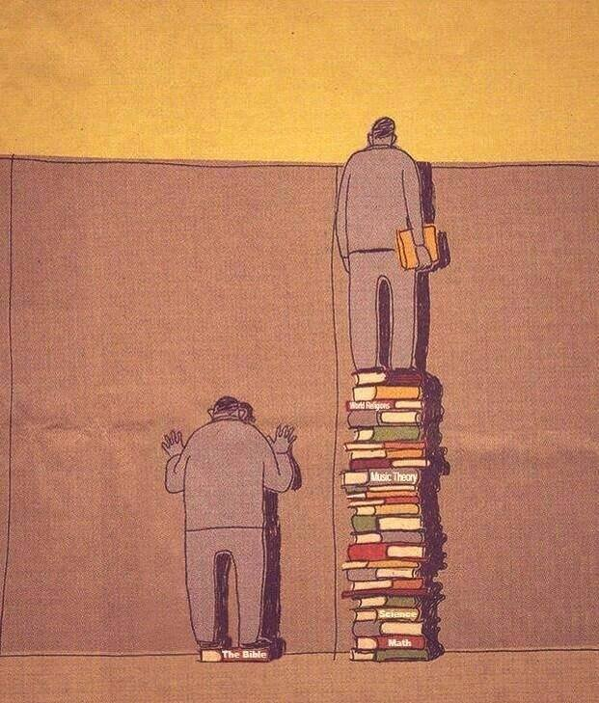 | "Sončni vzhod prebuja naravo,  branje knjig  razsvetljuje glavo."  Mongolski pregovor
Bralna značka za odrasle

Avtor dela: _________________________________________________________________________
Naslov dela: ________________________________________________________________________
Zakaj knjigo priporočate drugim?
__________________________________________________________________________________
__________________________________________________________________________________
__________________________________________________________________________________
__________________________________________________________________________________

Misel iz knjige:
__________________________________________________________________________________
__________________________________________________________________________________
__________________________________________________________________________________
__________________________________________________________________________________

Datum: Podpis (ni obvezen):
______________________________ _____________________________

